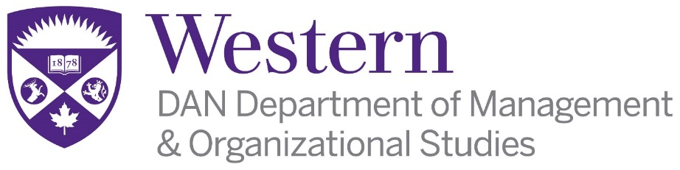 Faculty of Social Science

THE UNIVERSITY OF WESTERN ONTARIO
FACULTY OF SOCIAL SCIENCE
DAN Department of Management & Organizational Studies

The DAN Department of Management & Organizational Studies is an innovative and rapidly expanding interdisciplinary department in the Faculty of Social Science (FSS) at The University of Western Ontario (UWO) with over 3,000 students enrolled. This unique department combines management studies with a strong foundation in the social sciences. Candidates demonstrating a commitment to working in an interdisciplinary environment will be preferred. We invite you to visit our website: http://www.dan.uwo.ca.

LIMITED-TERM APPOINTMENT IN HUMAN RESOURCES

Applications are invited for a Limited-Term full time appointment for a period of two years (negotiable and renewable) at the rank of Lecturer in the area of Human Resources. Candidates for this position must have a graduate degree in a related discipline or equivalent professional designation. This is a full-time teaching position (research is not a component of the workload in this position). Applicants must possess a strong record of excellence in teaching ability, or evidence of potential in this area. The successful candidate will be expected to teach a broad cross-section of undergraduate courses in Human Resources. Contributing to ongoing curriculum and program development is also expected.

Salary will be commensurate with previous performance, qualifications and experience in accordance with the Collective Agreement. The effective date of appointment is July 1, 2019.

Interested candidates should send a curriculum vita, appropriate evidence of teaching performance, three academic letters of reference and a full-time faculty application (http://www.uwo.ca/facultyrelations/pdf/careers/Faculty/Application-FullTime-Faculty-Position-Form.pdf) to: Dan Shrubsole, Acting Chair, DAN Department of Management & Organizational Studies, The University of Western Ontario, 1151 Richmond Street, Social Science Centre, Room 4330, London, Ontario, N6A 5C2. The position will remain open until filled, review of applications will begin on June 1, 2019.

Positions are subject to budgetary approval. Applicants should have fluent written and oral communication skills in English. Western is committed to employment equity and diversity in the workplace and welcomes applications from women, members of racialized groups / visible minorities, Aboriginal persons, persons with disabilities, persons of any sexual orientation, and persons of any gender identity or gender expression.

In accordance with Canadian Immigration requirements, priority will be given to Canadian citizens and permanent residents.

Accommodations are available for applicants with disabilities throughout the recruitment process. If you require accommodations for interviews or other meetings, please contact Gloria Dawson by phone at 519-661-2111 ext: 83167.

